Name: Akshay Lavhaji Patil

GID: 158417

MySQL Assignment 1

1.

2.

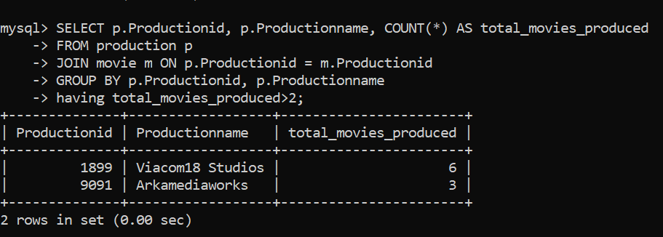

3.

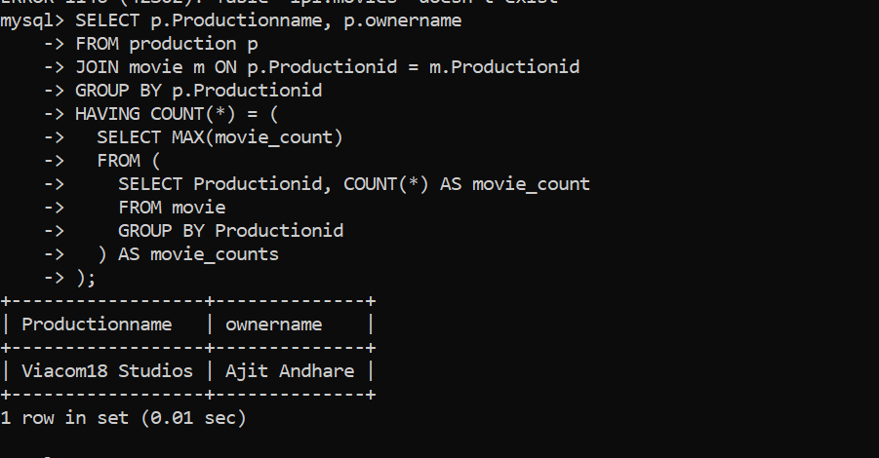

4.

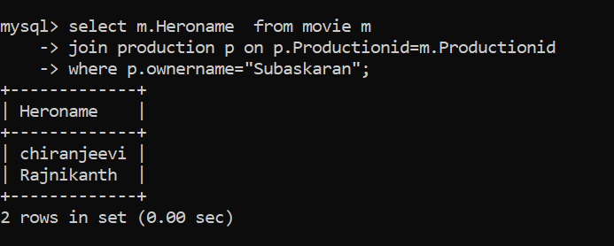

5.

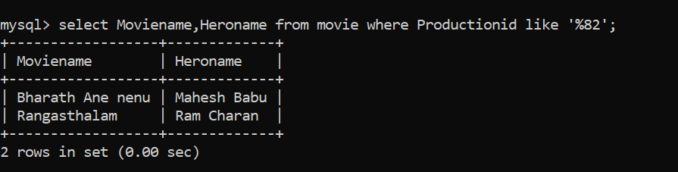

6.

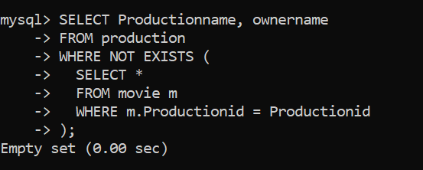

7.



8.

9.